USER MANUAL – BOCW ESTABLISHMENTS

Front End User
Step 1 Factory owner will visit to the department website www.hrylabour.gov.in. Then click on BOCW establishment.

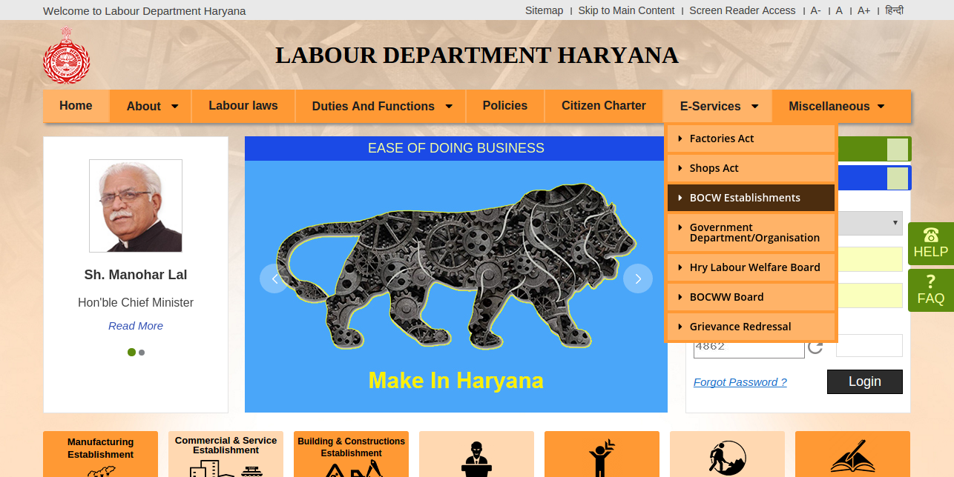
Or
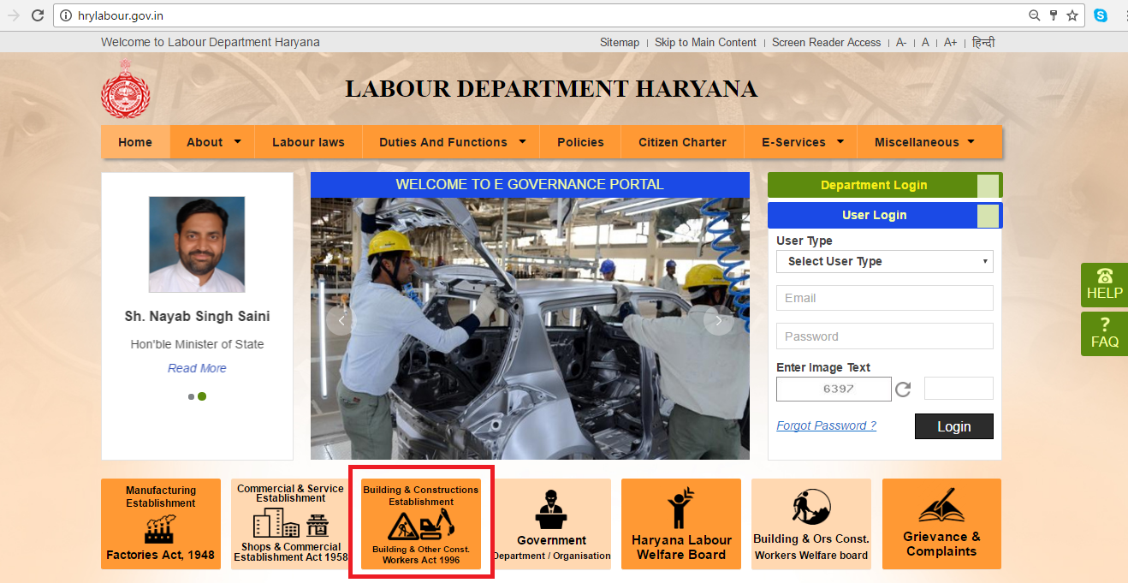
Applicant has to read all the instructions and tick on acknowledgement
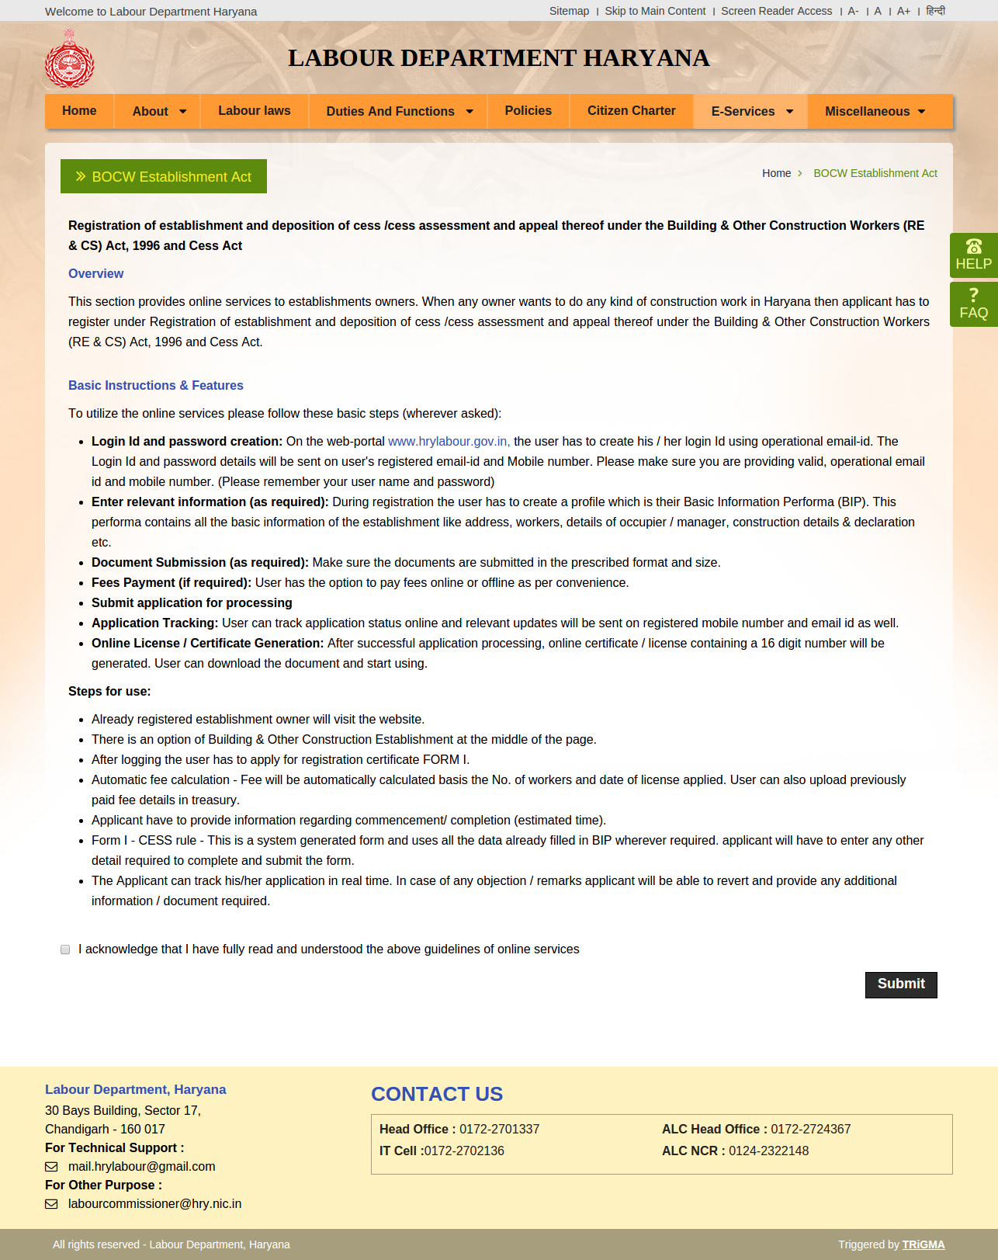
Step 2: Applicant will search the establishment name or establishment id and then click on “submit”.
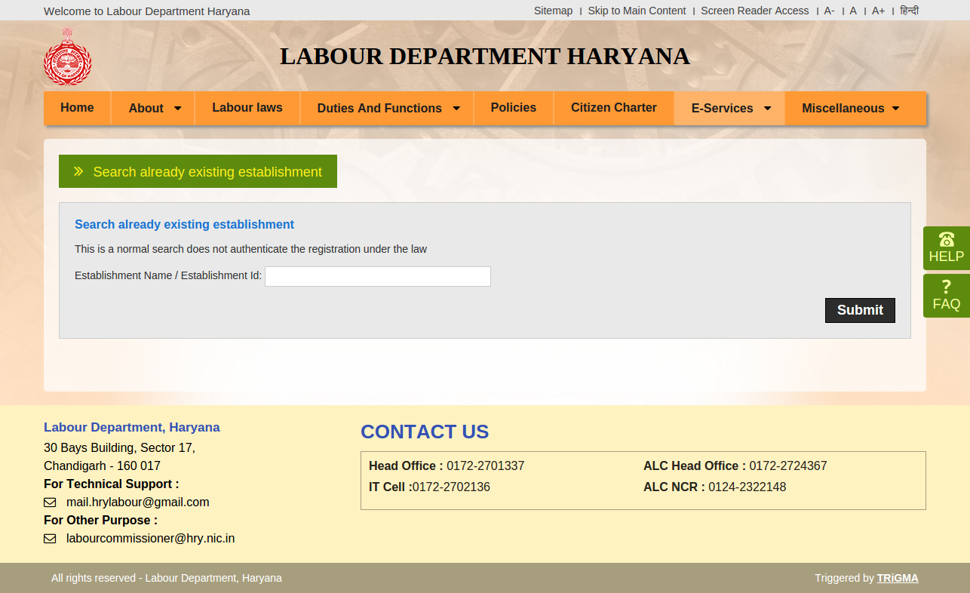

If establishment name or id matches to the establishment owner name then check the registered email id and go to home page and login to that id.
If establishment name does not match, then click on “Click here to fill basic information form”.
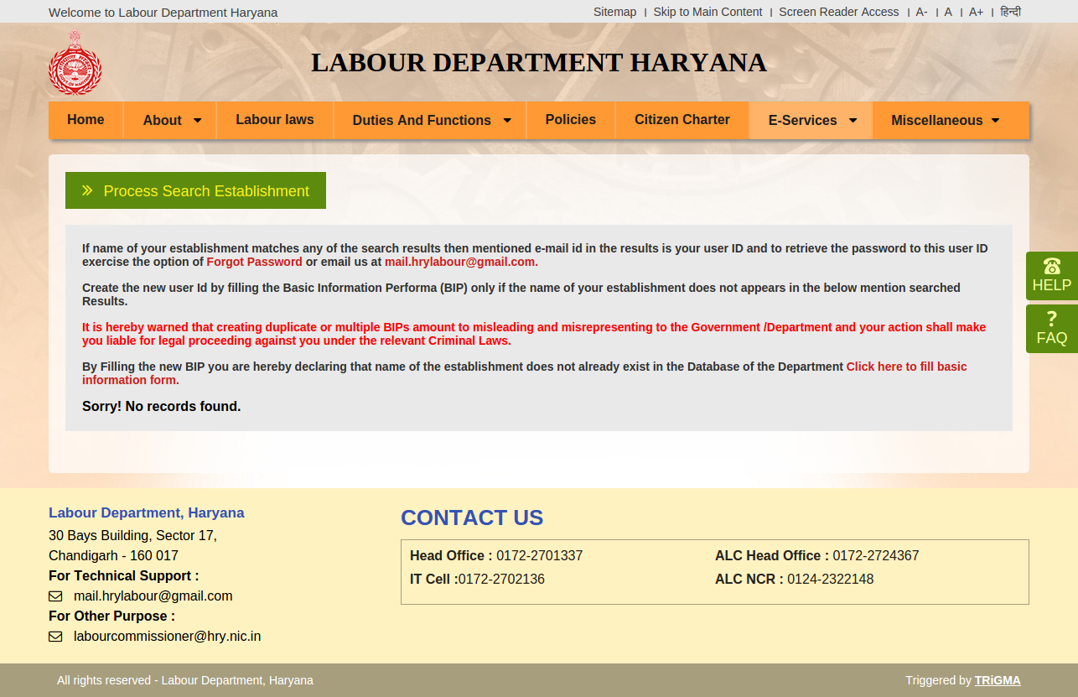

Next step is fill the required information as shown below.
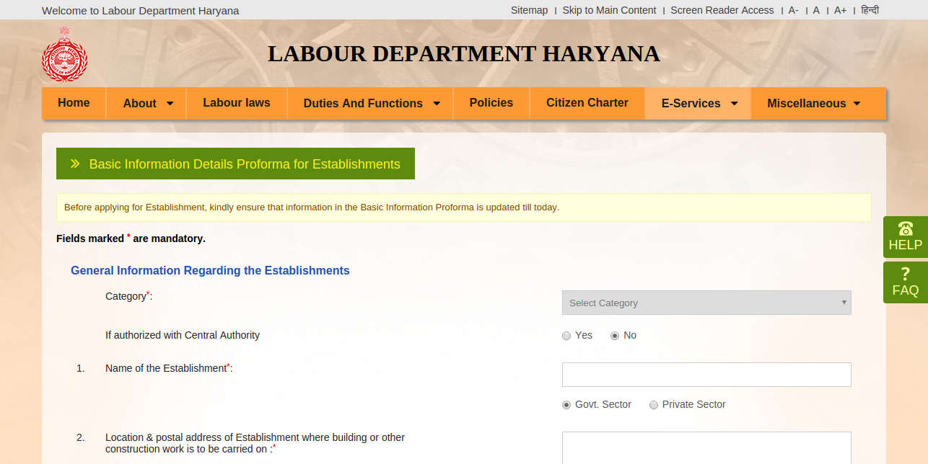
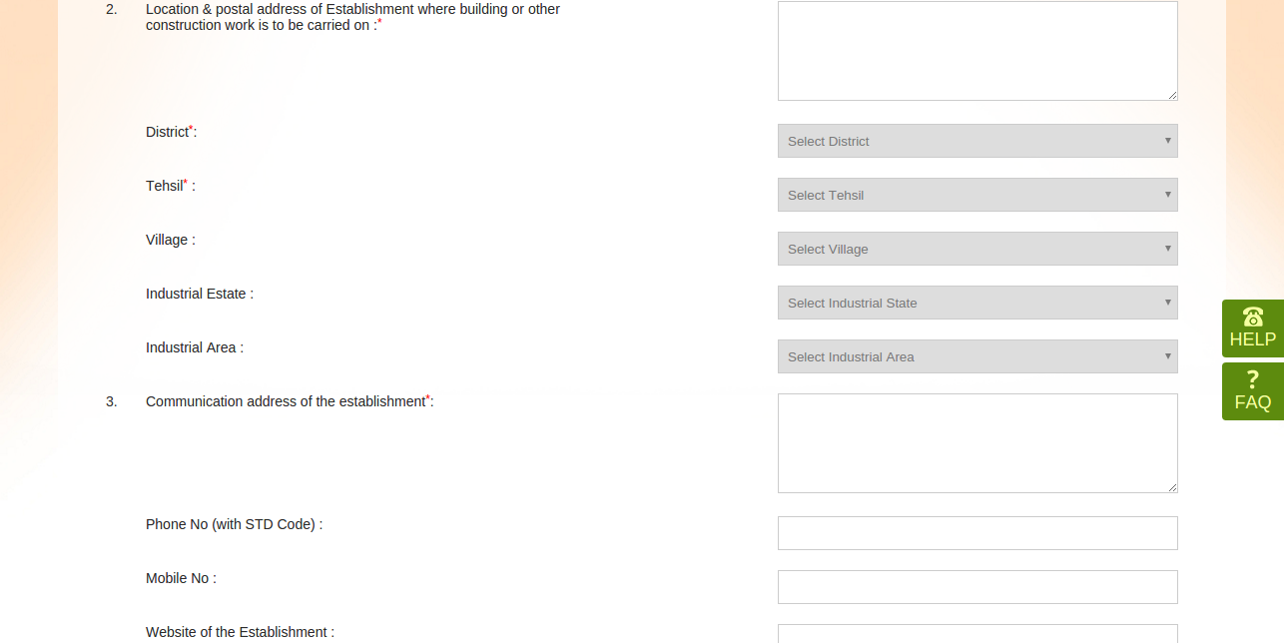
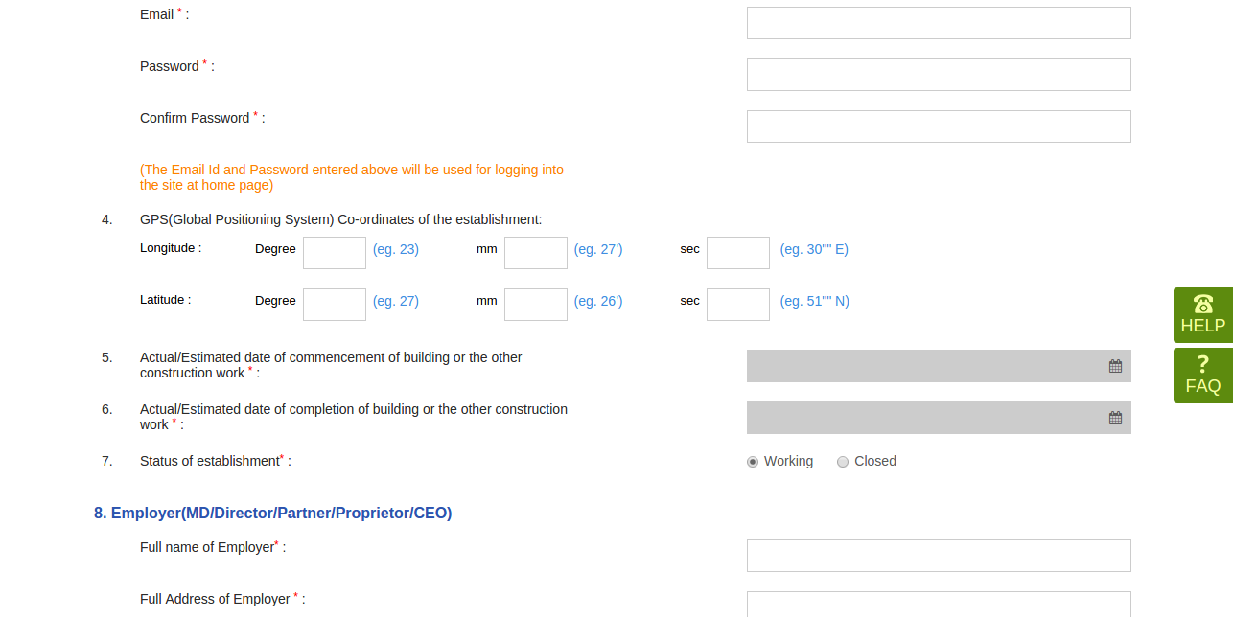
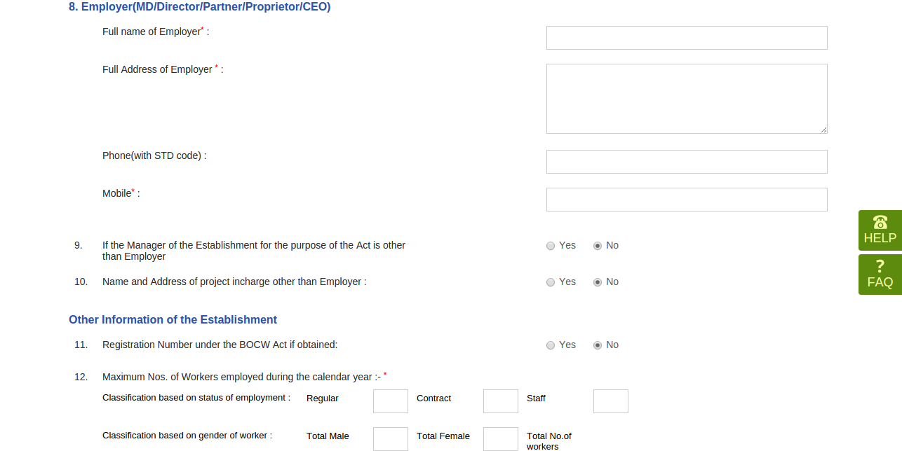
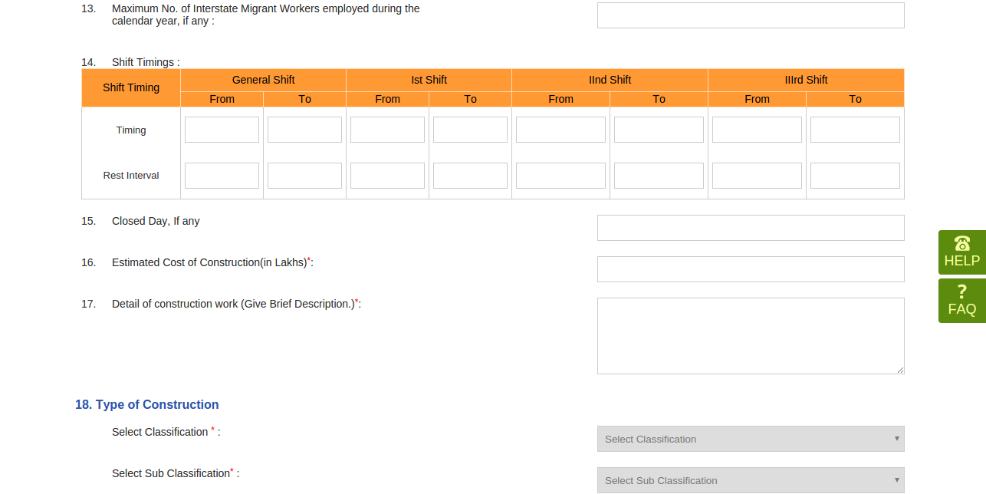
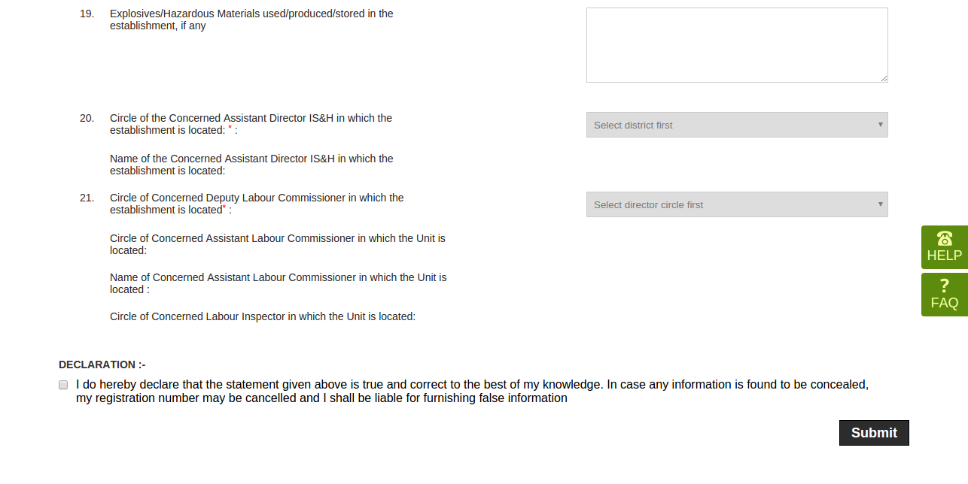

After filling all the information applicant has to tick the declaration and the click on “submit” button. Successful registered page will appear. as shown below.
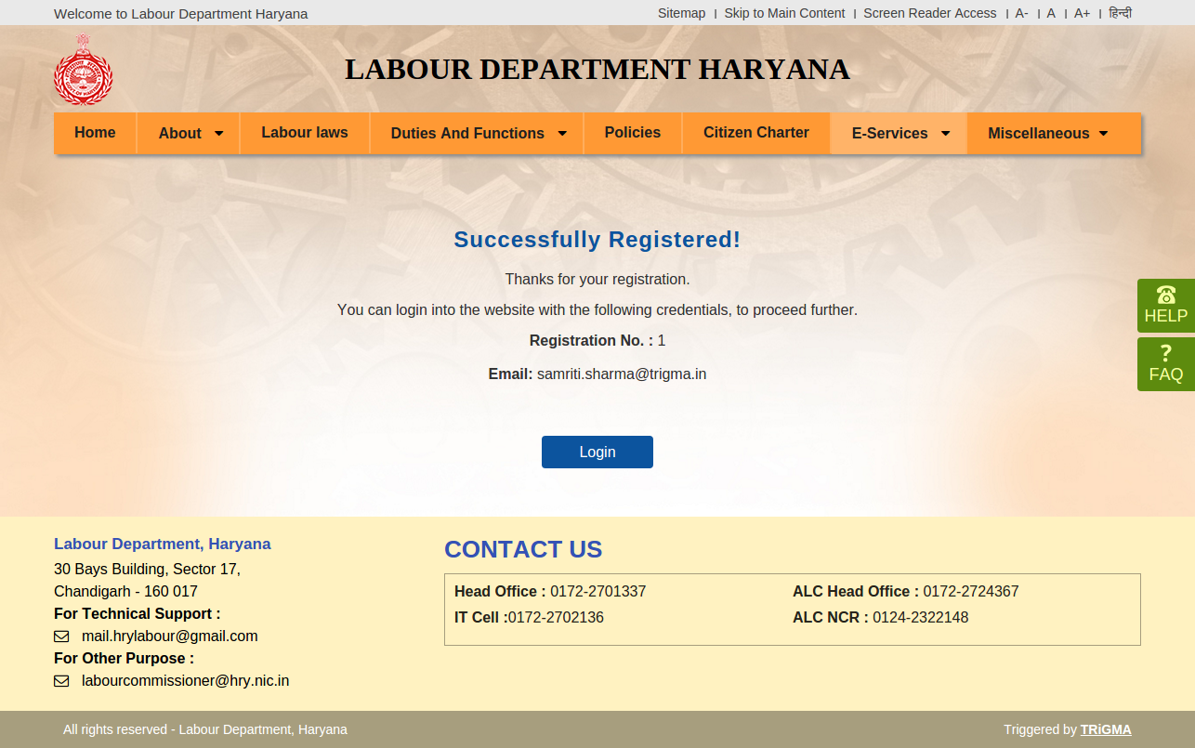

Establishment dashboard: - Applicant will have the complete information of his application.
- Edit option to edit the Basic information performa
- Applicant can download the Basic information performa in pdf format
- Balance fee information
- Notifications
- Employer details
- Other information of establishment
- Shift timing
- Type of construction
- other

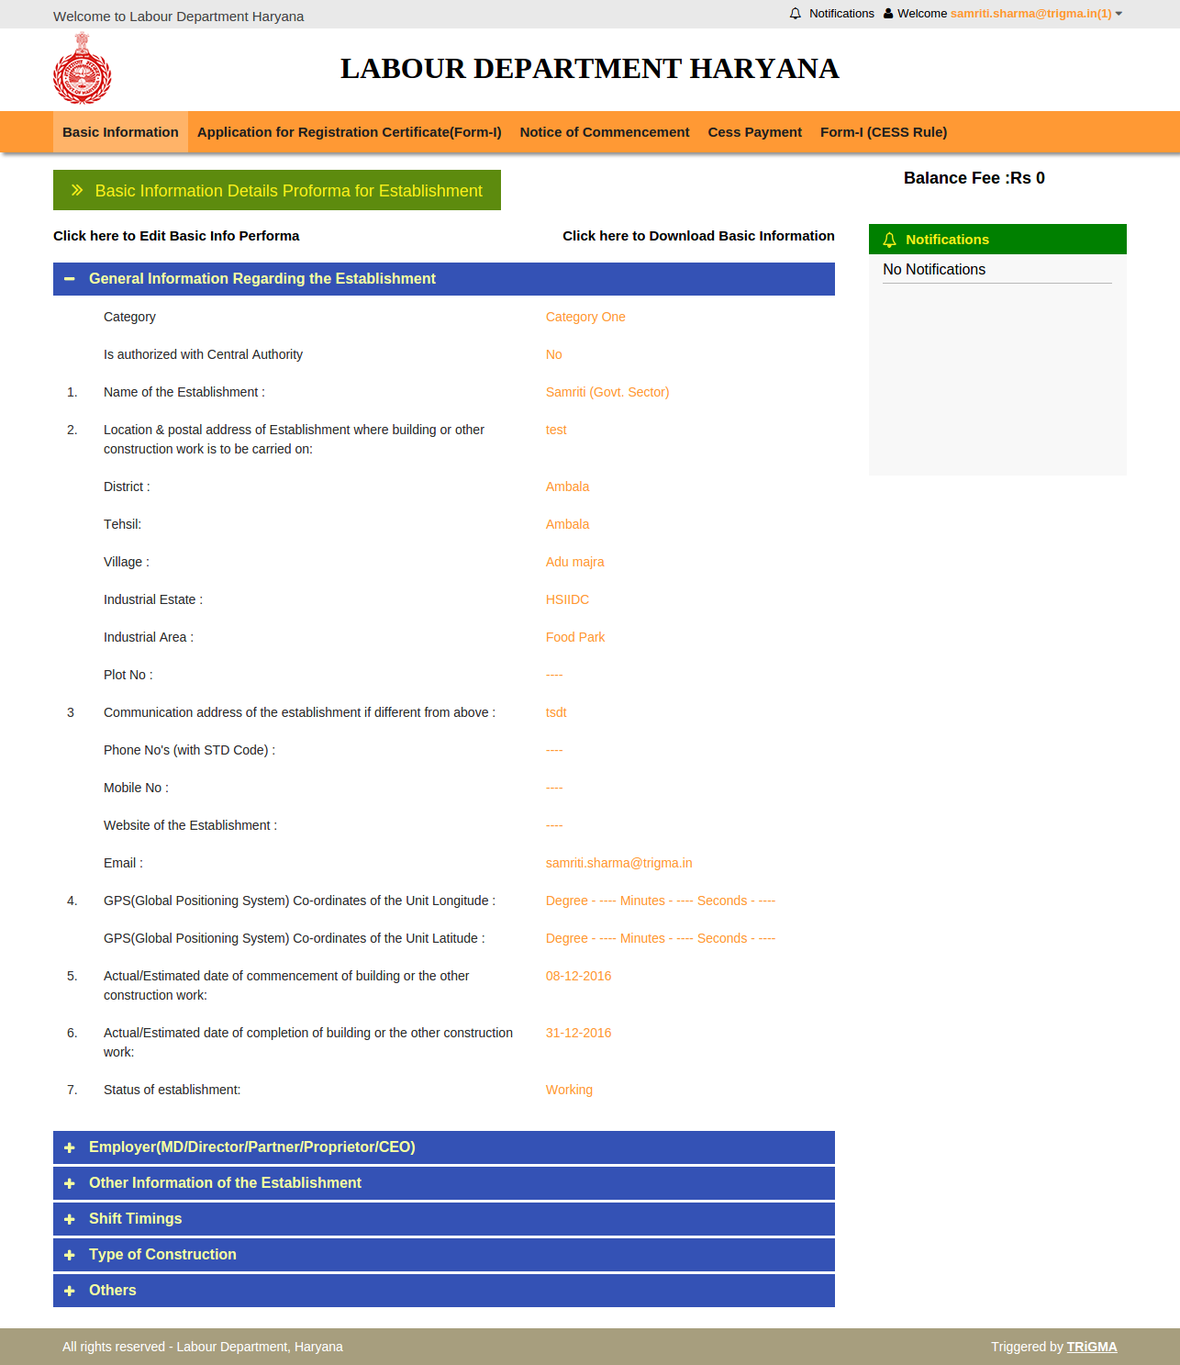

Then Click on Application for Registration certificate
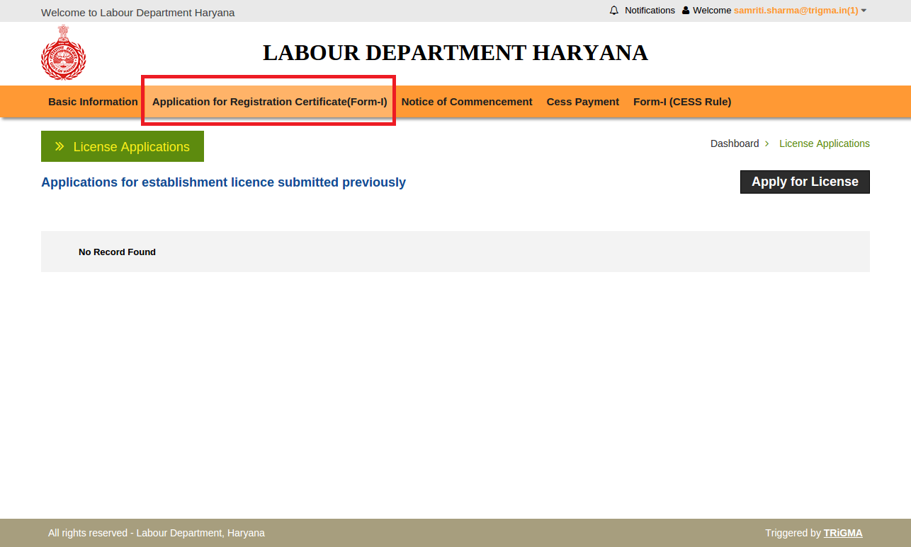

Form-I for fresh form.
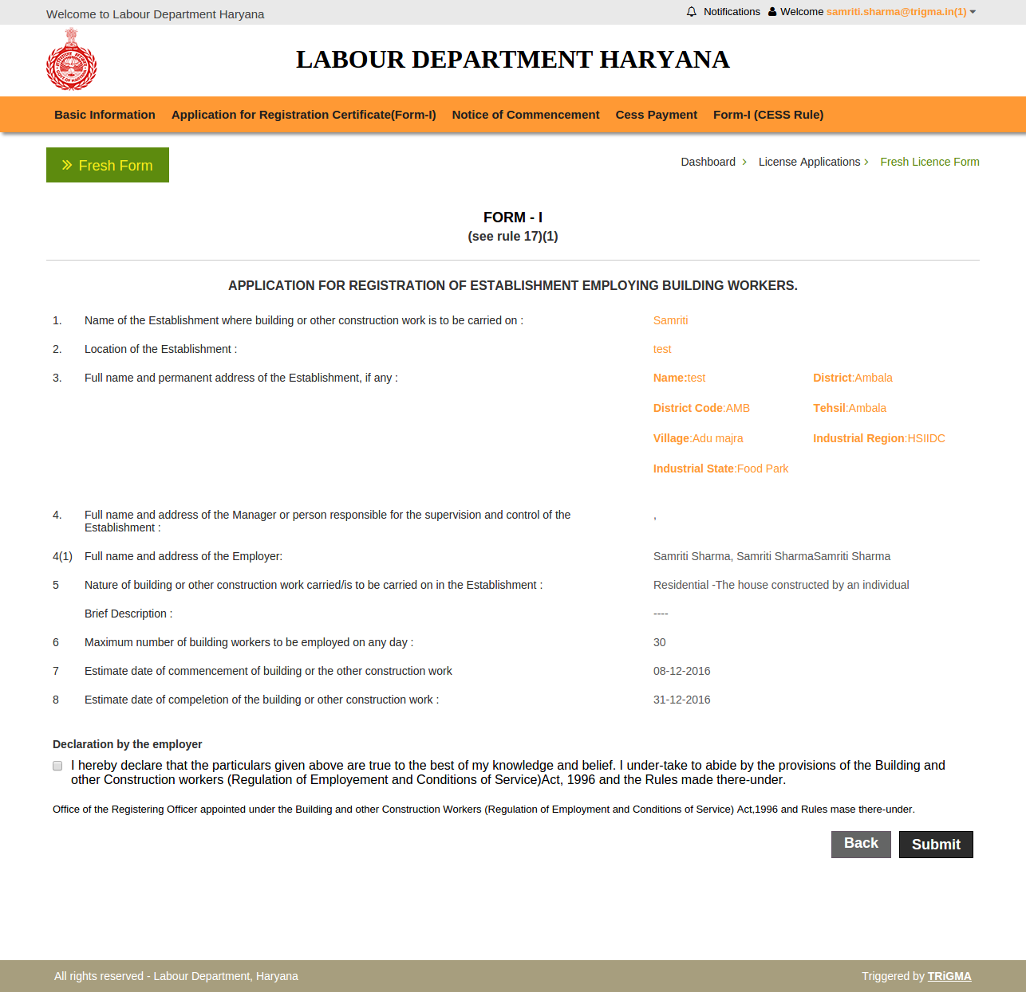

Establishment will upload the required documents.
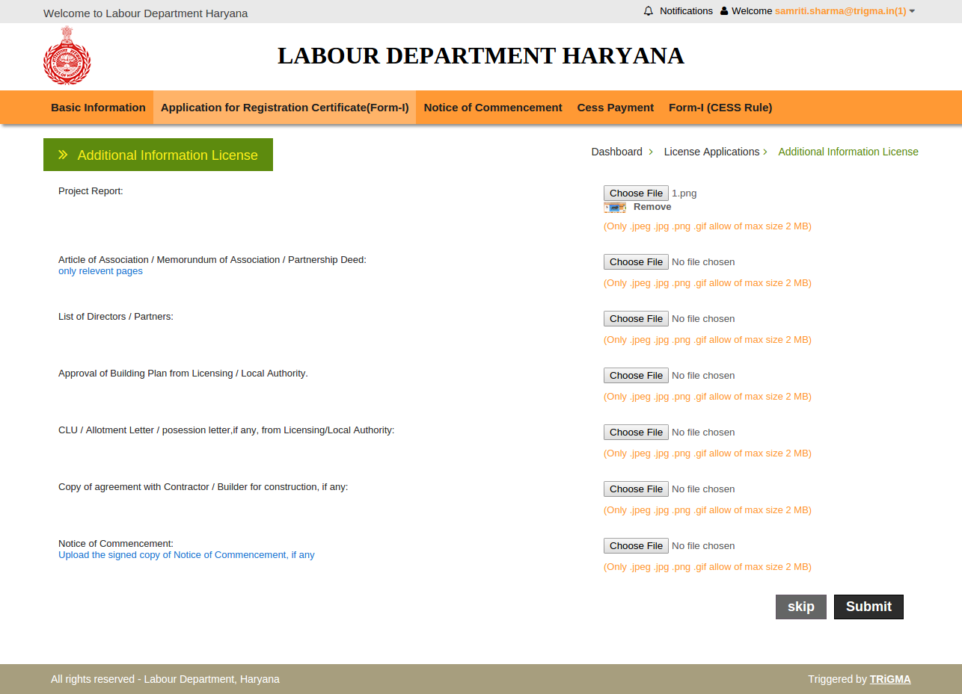

Dashboard of establishment: - Establishment will have the complete information.
To pay registration fees establishment have to follow the following steps they can pay the fees by clicking “Pay Now”.
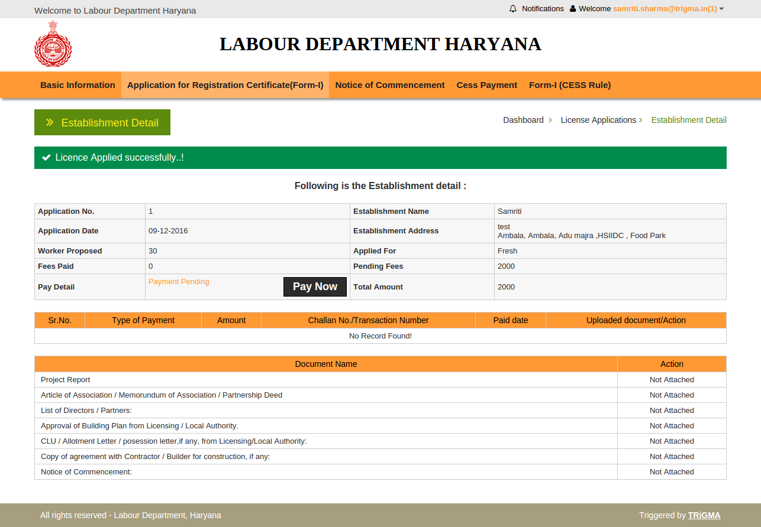

Then select the mode of payment , establishment want to pay online/ offline. Then select “ Select mode of Payment”. 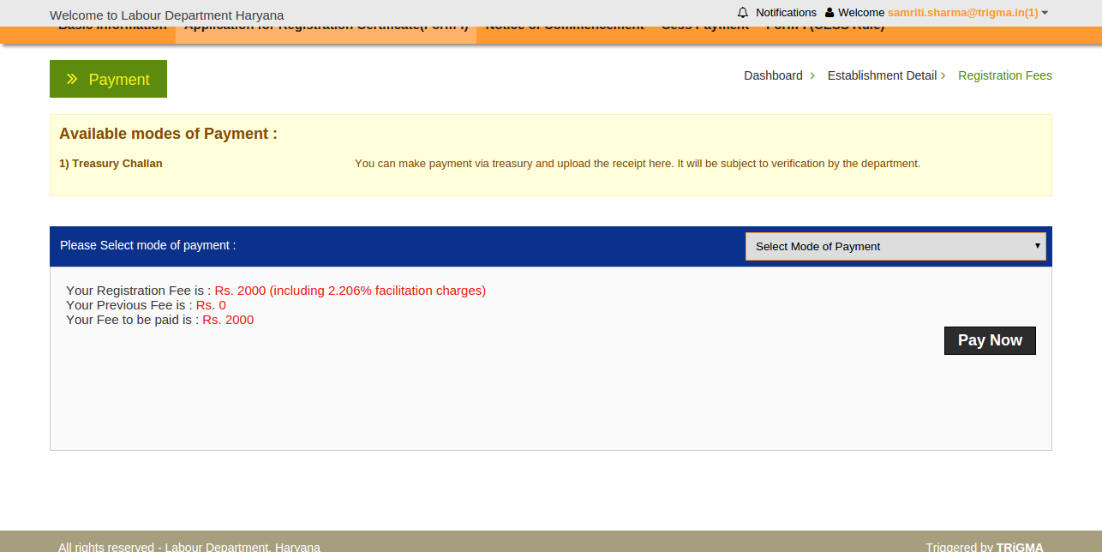
E-GRAS :- fee will be directly go to treasury online Payment system.
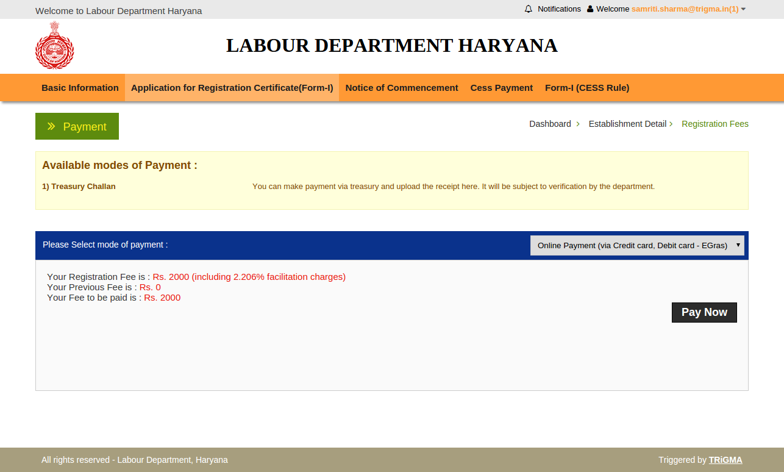
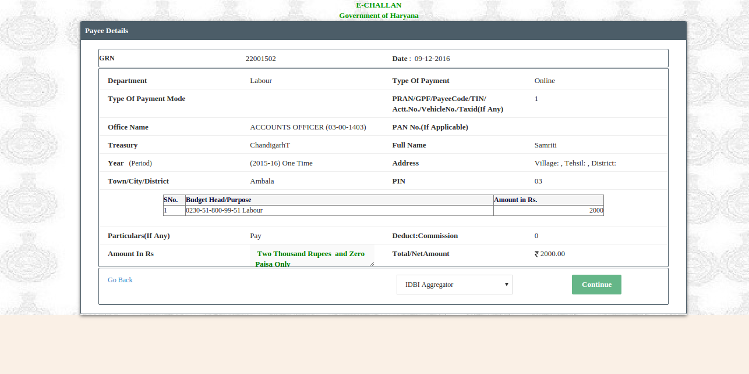

If establishment want to pay Treasury Challan offline payment then follow the following steps. Establishment have to fill the required details as shown below.
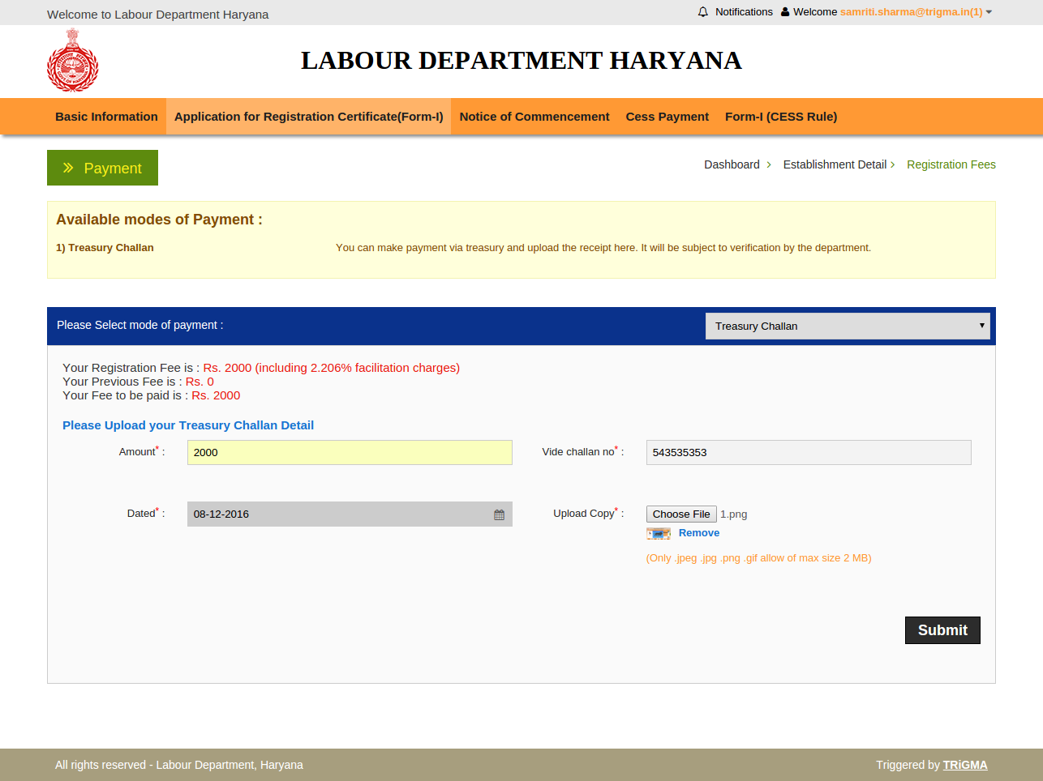

After successful payment below image will appear
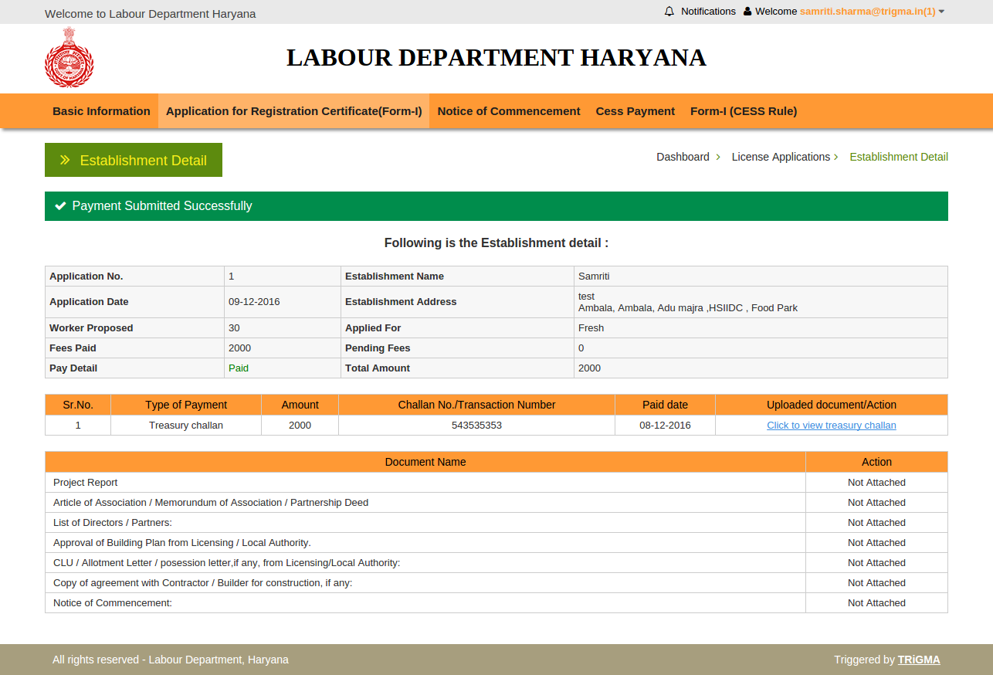
Next Step is “Notice of Commencement” and click on “view Application Process”. Click on Notice of Commencement as shown below
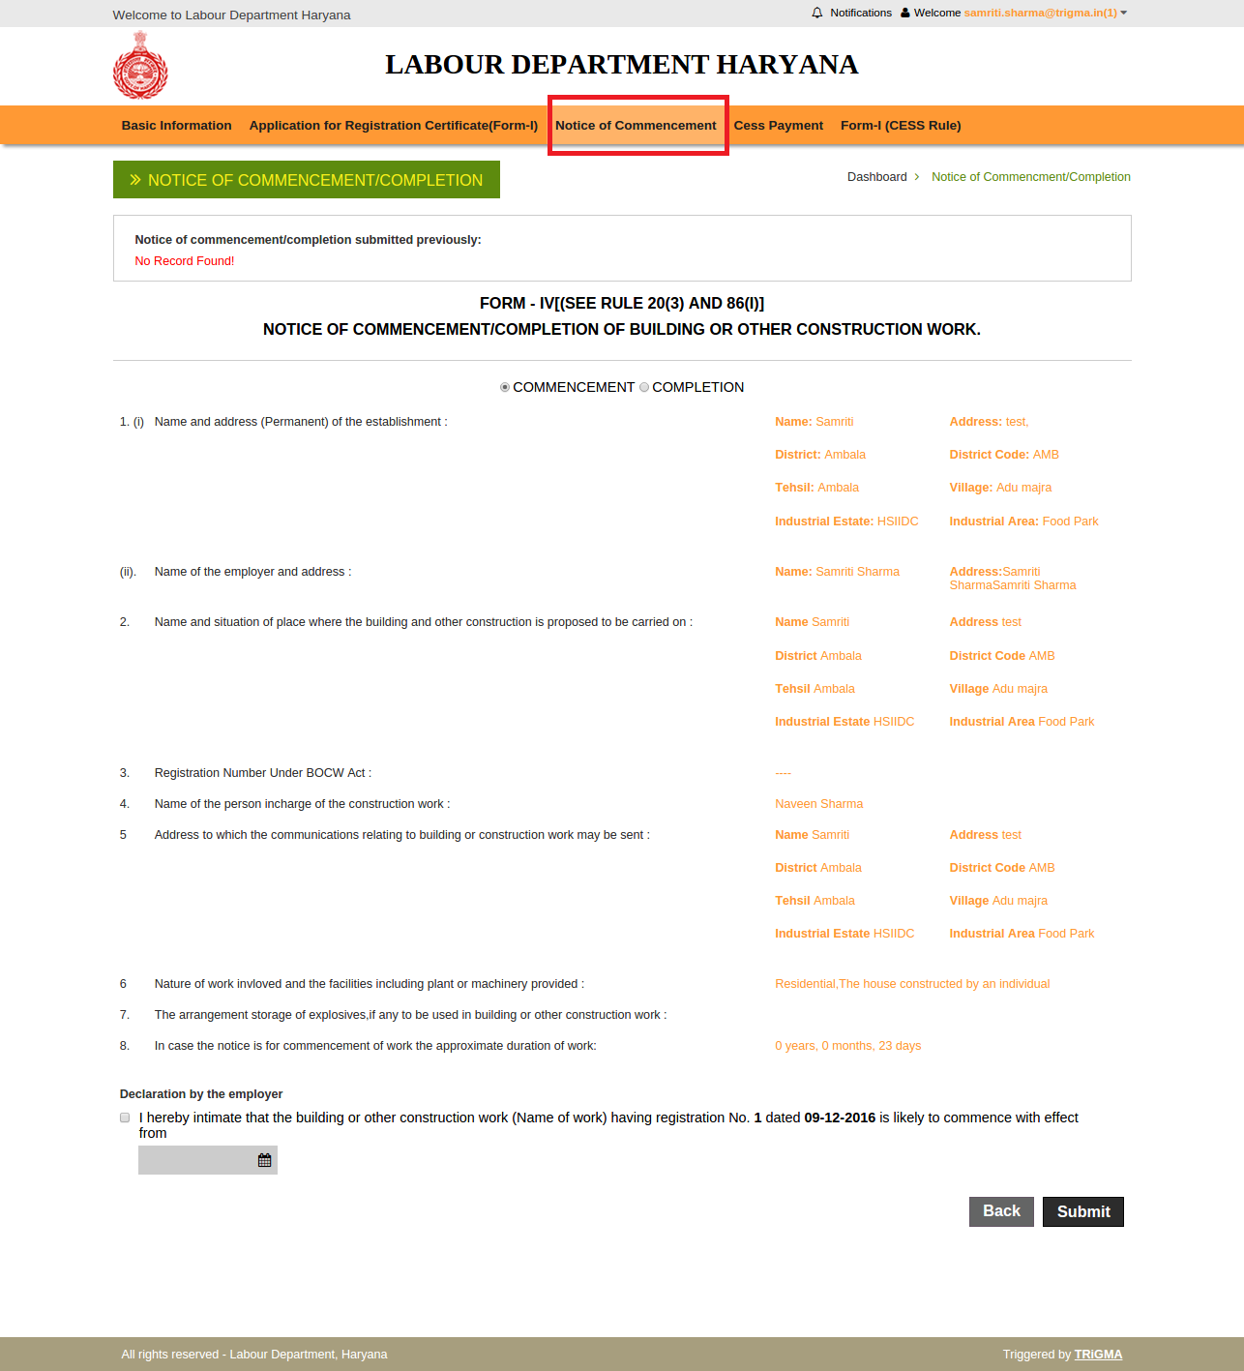

Fill all the required details and then click on submit button.
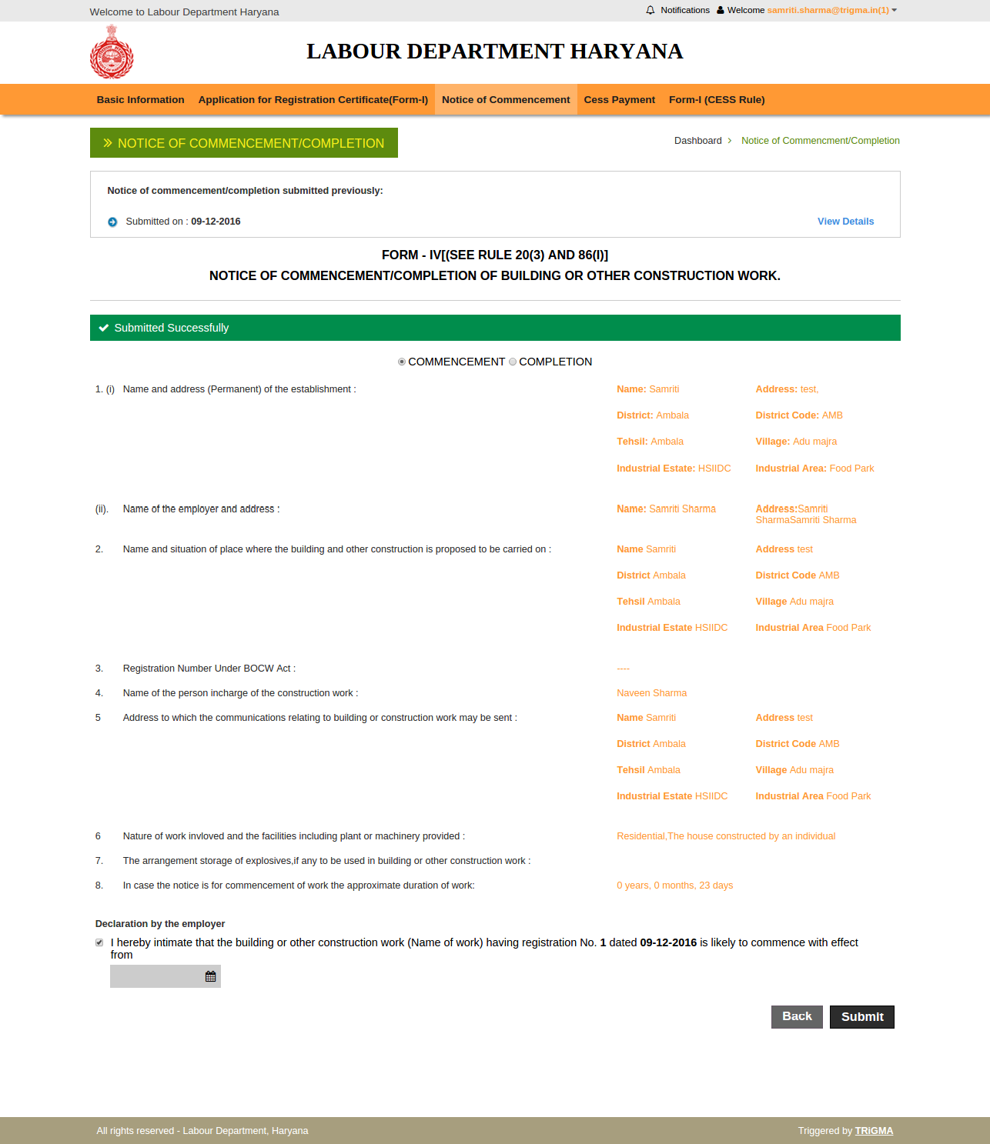

To preview the COMMENCEMENT the below screen will be shown.
CESS Payment: - to pay the CESS payment establishment has to select “CESS payment” then Select the mode of payment by clicking “Select Mode of Payment”.
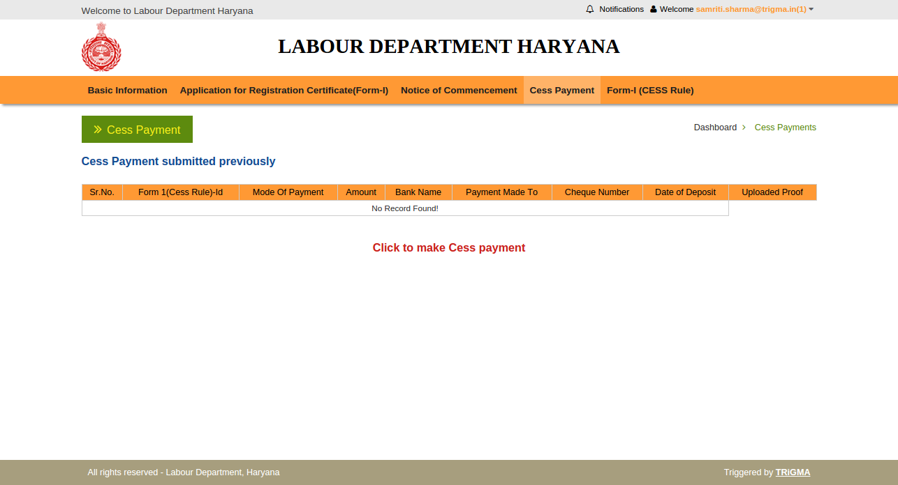
Select mode of payment for NEFT check the below image and fill the Amount and select the Form ID, then click on submit button.
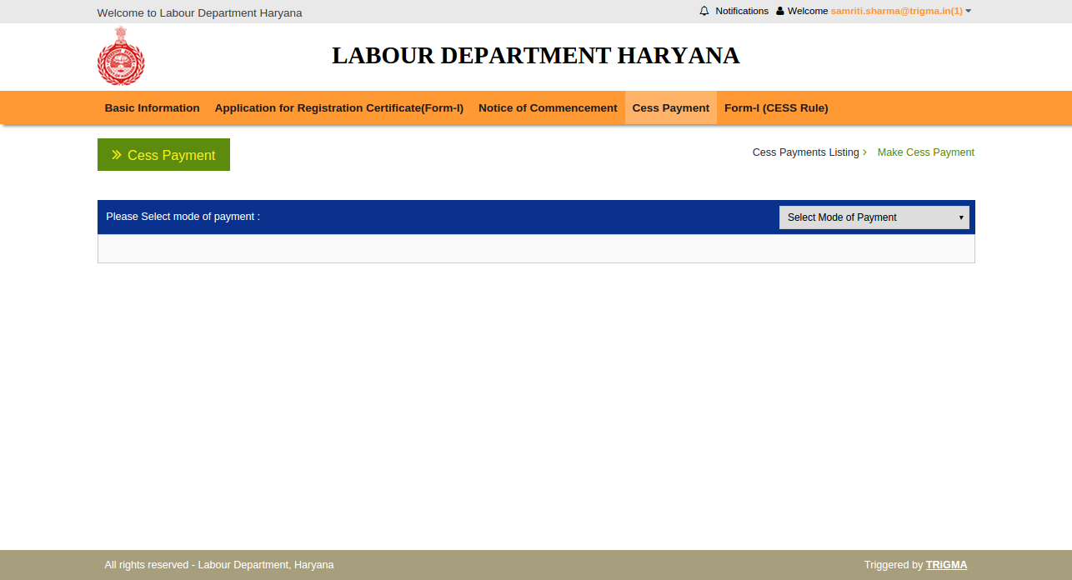
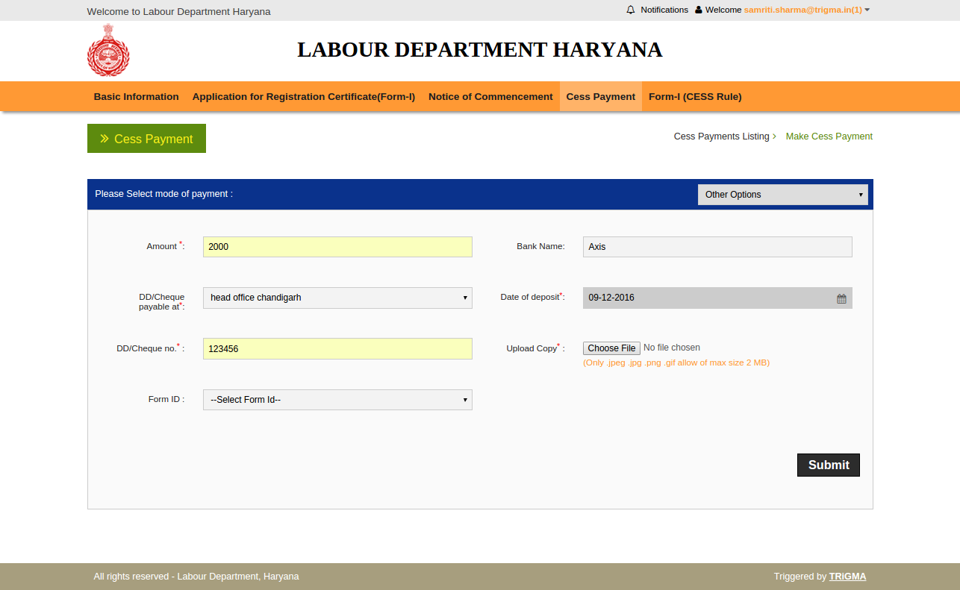

Successful payment submission.
